P525/2
CHEMISTRY
Paper 2
Jul / Aug. 2018
2 ½ hours

INTERNAL MOCK EXAMINATION 2018

Uganda Advanced Certificate of Education

CHEMISTRY

Paper 2

2 hours 30 minutes

INSTRUCTIONS TO CANDIDATES:

Answer FIVE questions including three questions from Section A and any two questions from Section B.
Begin each question on a fresh page.
Mathematical tables and graph papers are provided.
Non-programmable scientific electronic calculators may be used.
Illustrate your answers with equations where applicable.
[N=14, C = 12, O = 16, H = 1, 1 mol of a gas occupies 22.4 dm³at s.t.p.]

SECTION A:
Answer THREE questions from this section

- (a) (i) State the distribution law. (01 mark)
(ii) Give three conditions under which the law is valid. (1½ marks)
(b) Describe an experiment to show how the distribution coefficient of butanedioic acid between water and trichloromethane can be determined in the laboratory at room temperature. (06 marks)
(c) The table below shows the results of the partition of ammonia between
trichloromethane and 0.02 M metal (II) sulphate XSO₄ solution. The metal X forms a complex ion with ammonia of the formular [X(NH₃)_{n}]²⁺.

[NH₃(0.02 M XSO₄] / moldm⁻³ | 0.42 | 0.72 | 1.02 | 1.32 | 1.64
[NH₃(CHCl₃)] / moldm⁻³ | 0.01 | 0.02 | 0.03 | 0.04 | 0.05

- Plot a graph of [NH₃(0.02 MXSO₄] against [NH₃(CHCl₃)].
(03 marks)
- Determine the co-ordination number “n” of the metal (II) ion and hence the formular of the complex. (02 marks)
- Determine the partition coefficient of ammonia between the aqueous layer and the organic layer. (1½ marks)
(d) (i) Define the term steam distillation. (01 mark)
(ii) A mixture of phenylamine and water was steam distilled at 98ºC and 101.325 Kpa. Calculate the percentage by mass of phenylamine in the distillate if the saturated vapour pressure of water at 98ºC is 96 Kpa.
(03 marks)
(iii) State two advantages of steam distillation method of purification of substances. (02 marks)

- The elements Fluorine, chlorine, bromine and iodine belong to group VII of the periodic table.
- Explain the trend in;
- The bond dissociation enthalpy of the elements.
- The melting points of the elements. (05 marks)
- Illustrating your answer with suitable equation, compare the reaction of chlorine and fluorine with;
- Carbon
- Water
- Hot concentrated potassium hydroxide solution. (07 marks)
Give reasons for the difference in the chemistry of the two elements if any. (01 mark)
- Iodine was added to dilute sodium hydroxide solution and the resultant solution warmed.
- State what was observed. (01 mark)
- Write equation(s) for the reaction(s). (02 marks)
- Commercial bleach can be obtained by bubbling chlorine gas into cold dilute sodium hydroxide. 10.0 cm³ of the bleach solution was diluted to 250 cm³ with distilled water. 20.0 cm³ of this solution was acidified with dilute hydrochloric acid and excess potassium iodide solution added. The liberated iodine required 9.0 cm³ of 0.08M sodium thiosulphate solution. Calculate the mass of chlorine required to produce 1 dm³ of the commercial bleach.
(05 marks)

- (a) Write equations to show how each of the following compounds can be
synthesized. In each case indicate the reagents and the conditions for the reactions.
- Ag₂C₂ to propan – 2 -01 (3½ marks)
- Methylamine from ethanol (03 marks)
- CH₃ – CH – OCH₃ from ethene. (03 marks)
OCH₃
N - N
- Cyclohexene to (04 marks)

(b) Complete the following equations and outline a suitable mechanism for the reaction.
OCH₃
Excess conc HI
- (02½ marks)
reflux

NaOH(aq)
- H₂CO (04 marks)
Cold

- (a) What is meant by the terms;
- Order of reaction
- Rate law
- Activated complex (03 marks)
(b) Describe an experiment to show that the reaction between potassium peroxodisulphate solution and potassium iodide solution is first order with respect to potassium peroxodisulphate. (06 marks)
(c) Sucrose is hydrolysed in dilute acid to give a mixture of glucose and fructose.
H⁺(aq)
C₁₂H₂₂O₁₁(aq) + H₂O(l) C₆H₁₂O₆(aq) + C₆H₁₂O₆(aq).

The graph below shows a plot of the natural logarithm of the molar concentration of sucrose remaining at regular time intervals.
(ln[s] = ln[C₁₂H₂₂O₁₁])

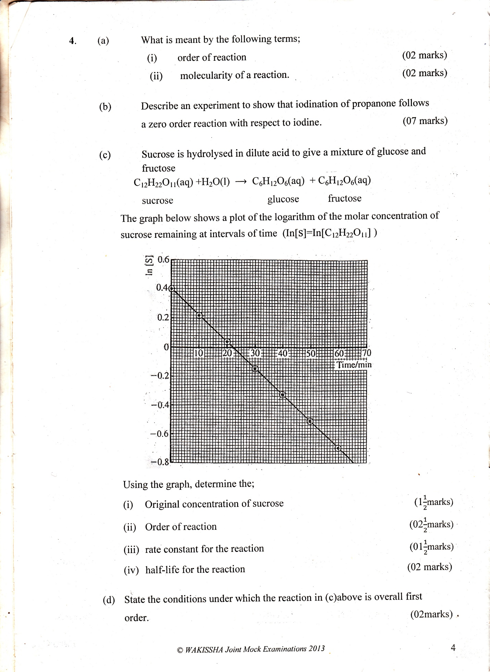

Using the graph, determine the;
- Initial concentration of sucrose. (01 mark)
- Order of reaction (02 marks)
- Rate constant for the reaction (02 marks)
- Half life for the reaction. (01 mark)
(d) State the conditions under which the reaction in (c) above is over all first order. (02 marks)
(e) (i) Explain how a catalyst affects the rate of a chemical reaction.
(02 marks)
(ii) Write an expression to show the relationship between rate constant and the activation energy. (01 mark)

SECTION B
Answer TWO questions from this section.

- (a) Compound X with molecular formular C₃H₉N reacts with sodium nitrite
solution and concentrated hyrochloric acid forming compound Y with evolution of a colourless gas Z.
- Identify gas Z (½ marks)
- Write the structure and I.U.P.A.C names of all the possible isomers
of X. (02 marks)
(b) Compound Y reacts with sodium metal evolving a colourless gas and forms a yellow precipitate with sodium iodate (I) solution.
(i) Identify Y (01 mark)
(ii) Name the yellow precipitate (½mark)
- Write equation for the reaction between Y and sodium iodate
(I) solution. (1½ mark)

(c) Write equation(s).
(i) For the reaction between Y and ethanoic acid in the presence of
concentrated sulphuric acid and outline a mechanism for the reaction.
(4½ marks)
(ii) To show how compound Y can be converted into
2 – methyl – 2 – hydroxylpropanoic acid. (03 marks)
(iii) For the reaction between Y and hot concentrated orthophosphoric acid.
(01 mark)
(d) Compound Y was heated with acidified potassium dichromate (VI) solution to form compound W.
(i) State what would be observed. (01 mark)
(ii) Write equation and outline a mechanism for the reaction between W and acidified sodium sulphite solution. (04½ marks)

- (a) Define the following terms;
- Electrolytic conductivity (01 mark)
- Molar conductivity (01 mark)
(b) Draw sketch graphs for the variation of electrolytic conductivity with volume of the acid when;
(i) 0.1 M sodium hydroxide solution is titrated with 1 M hydrochloric acid. (02 marks)
(ii) 0.1 M ammonia solution is titrated with 1M hydrochloric acid.
(02 marks)
(c) Explain the shapes of the graphs in (c). (06marks)
(d) The molar conductivities at infinite dilution at 25ºC for some ions are shown in the table.

ION | Molar conductivity at infinite dilution (Ω⁻¹ cm² mol⁻¹)
H⁺ | 350
OH⁻ | 200
Na⁺ | 50
Cl⁻ | 79

Calculate the electrolytic conductivity of;
- A 0.01M solution of hydrochloric acid. (02 marks)
- The solution in (c) (i) above, when half neutralized by 0.01M sodium hydroxide solution. (03 marks)
- The solution formed when the solution in (c) (i) is just neutralized by addition of the same volume of 0.01M sodium hydroxide. (03 marks)

- Explain the following observation;
- Liquid oxygen has a lower boiling point than nitrogen monoxide of almost similar molecular mass. (03 marks)
- Methanoic acid gives a red precipitate on warming with Fehling’s solution whereas propanoic acid gives no observable change. (3½ marks)
- A mixture of water and chlorobenzene boils at a temperature considerably below the boiling point of either pure liquid. (03 marks)
- When dilute sulphuric acid is added to an aqueous solution of potassium manganate (VI), the solution turns from green to purple with the formation of black particles. (3½ marks)
- When ammonia solution was added to a saturated solution of silver phosphate, its solubility increased but when silver nitrate solution was added to the solution, the solubility of silver phosphate decreased. (04 marks)
- The pH of the following bases decreases in the order;
(CH₃)₂NH > CH₃NH₂ > (CH₃)₃N (03 marks)

- (a) (i) Name one source of vegetable oil. (01 mark)
(ii) Briefly describe how soap can be prepared from the vegetable oil you have named in (a) (i) above. (04 marks)

(b) (i) During the preparation of soap from Z, C₃H₅(OCOR)₃, 1.108g of Z
was heated with 10.0cm³ of 1.0 M sodium hydroxide solution for some time and then cooled. The unreacted alkali required 4.0 cm³ of 0.1 M hydrochloric acid for complete neutralisation.
Determine the relative formular mass of Z. (04 marks)

(ii) Explain why soap cannot be used effectively in strongly acidified medium. (03 marks)
(c) Soap and detergents are surfactants.
(i) Explain the term surfactant (01 mark)
(ii) Name one active ingredient in soap. (01 mark)
- Outline the method of synthesizing a detergent starting from
CH₃(CH₂)₉CH = CH₂ . Illustrate with equation in each case.
(05 marks)

END

